Michael Santoro

Bradley Morales

Julio Sarzosa

Progress Report 1

**Description:**

For this progress report, we were tasked to create a MIPS CPU that is capable of performing 8 different arithmetic instructions. Of those 8 instructions, 7 of them are R-Type, those being add, sub, and, or, not, nand, and slt. The last instruction, an I-Type instruction is addi. The major components of this version of the processor are the ALU, Register File, and the Instruction Memory.

**Instruction Set:**

| Instruction | OpCode | RegDst | ALUsrc | RegWrite | ALUCtl |
| --- | --- | --- | --- | --- | --- |
| add | 0000 | 1 | 0 | 1 | 0010 |
| sub | 0001 | 1 | 0 | 1 | 0110 |
| and | 0010 | 1 | 0 | 1 | 0000 |
| or | 0011 | 1 | 0 | 1 | 0001 |
| nor | 0100 | 1 | 0 | 1 | 1100 |
| nand | 0101 | 1 | 0 | 1 | 1101 |
| slt | 0110 | 1 | 0 | 1 | 0111 |
| addi | 0111 | 0 | 1 | 1 | 0010 |



**Logic Diagrams:**

**ALU Diagram:**

**CPU Diagram:**

**16-Bit Full Adder Diagram:**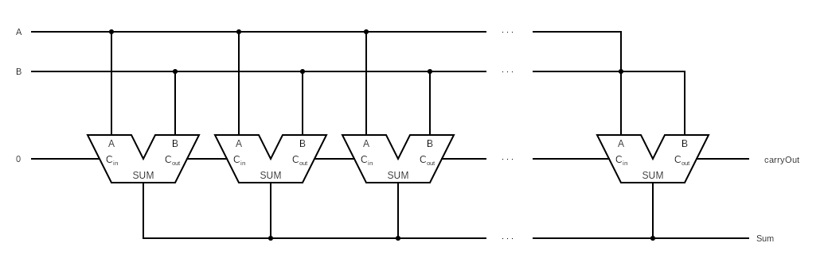

Note: The software used to create this diagram represents a full adder as the shape of an ALU. In this diagram these are supposed to be 16 Full-Adders strung together.

**16-Bit 2x1 Multiplexor:**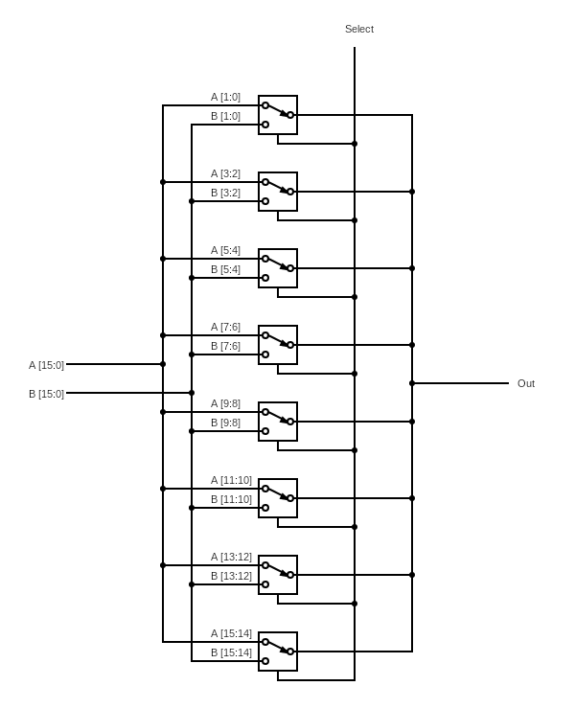

**Main Control Diagram:**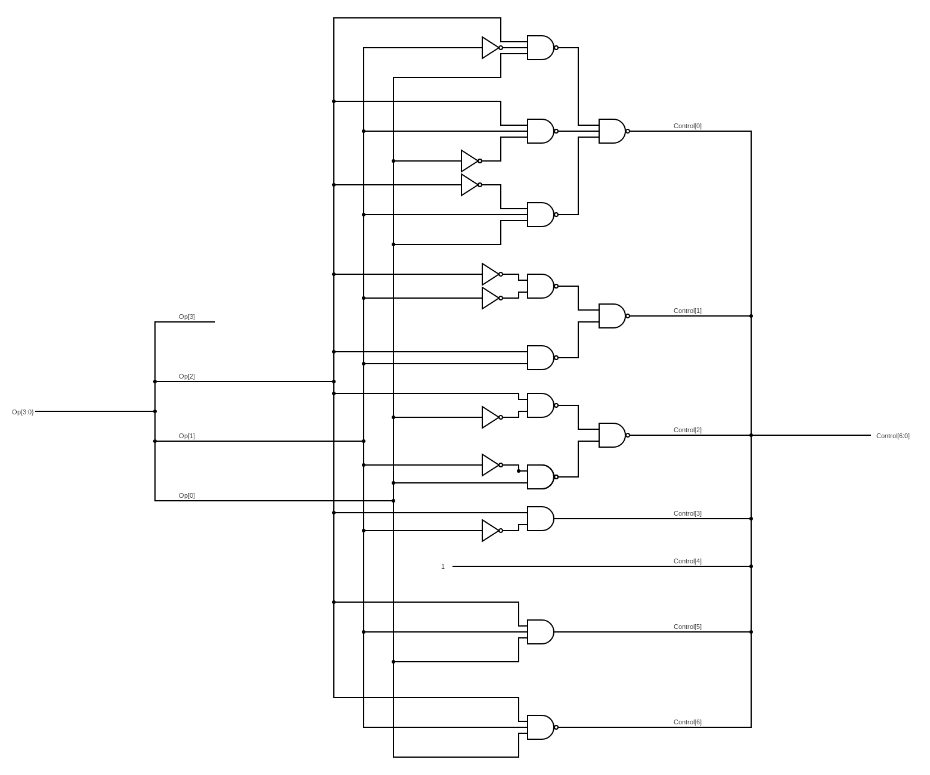

**Verilog Code:**

// Michael Santoro

// Julio Sarzosa

// Bradley Morales

// Progress Report 1

module reg_file (RR1,RR2,WR,WD,RegWrite,RD1,RD2,clock);

input [1:0] RR1,RR2,WR;

input [15:0] WD;

input RegWrite,clock;

output [15:0] RD1,RD2;

reg [15:0] Regs[0:3];

assign RD1 = Regs[RR1];

assign RD2 = Regs[RR2];

initial Regs[0] = 0;

always @(negedge clock)

if (RegWrite==1 & WR!=0)

Regs[WR] <= WD;

endmodule

// 16-bit MIPS ALU in Verilog using modified template of 4-bit ALU

module ALU (op,a,b,result,zero);

input [15:0] a;

input [15:0] b;

input [3:0] op;

output [15:0] result;

output zero;

wire c1,c2,c3,c4,c5,c6,c7,c8,c9,c10,c11,c12,c13,c14,c15,c16;

//16 single bit alu's

ALU1 alu0 (a[0], b[0], op[3], op[2], op[1:0],set,op[2],c1,result[0]);

ALU1 alu1 (a[1], b[1], op[3], op[2], op[1:0],1'b0, c1, c2,result[1]);

ALU1 alu2 (a[2], b[2], op[3], op[2], op[1:0],1'b0, c2, c3,result[2]);

ALU1 alu3 (a[3], b[3], op[3], op[2], op[1:0],1'b0, c3, c4,result[3]);

ALU1 alu4 (a[4], b[4], op[3], op[2], op[1:0],1'b0, c4, c5,result[4]);

ALU1 alu5 (a[5], b[5], op[3], op[2], op[1:0],1'b0, c5, c6,result[5]);

ALU1 alu6 (a[6], b[6], op[3], op[2], op[1:0],1'b0, c6, c7,result[6]);

ALU1 alu7 (a[7], b[7], op[3], op[2], op[1:0],1'b0, c7, c8,result[7]);

ALU1 alu8 (a[8], b[8], op[3], op[2], op[1:0],1'b0, c8, c9,result[8]);

ALU1 alu9 (a[9], b[9], op[3], op[2], op[1:0],1'b0, c9, c10,result[9]);

ALU1 alu10 (a[10],b[10],op[3], op[2], op[1:0],1'b0, c10, c11,result[10]);

ALU1 alu11 (a[11],b[11],op[3], op[2], op[1:0],1'b0, c11, c12,result[11]);

ALU1 alu12 (a[12],b[12],op[3], op[2], op[1:0],1'b0, c12, c13,result[12]);

ALU1 alu13 (a[13],b[13],op[3], op[2], op[1:0],1'b0, c13, c14,result[13]);

ALU1 alu14 (a[14],b[14],op[3], op[2], op[1:0],1'b0, c14, c15,result[14]);

ALUmsb alu15 (a[15],b[15],op[3], op[2], op[1:0],1'b0, c15, c16,result[15],set);

nor nor1(zero,result [15:0]);

endmodule

// 1-bit ALU for bits 0-14

module ALU1 (a,b,ainvert,binvert,op,less,carryin,carryout,result);

input a,b,less,carryin,ainvert, binvert;

input [1:0] op;

output carryout,result;

wire sum, a_and_b, a_or_b, b_inv, a_inv;

// Choose if we use a or a invert

not not1(a_inv, a);

mux2x1 mux1(a,a_inv,ainvert,a1);

// Chose if we use b or b invert

not not2(b_inv, b);

mux2x1 mux2(b,b_inv,binvert,b1);

and and1(a_and_b, a1, b1);

or or1(a_or_b, a1, b1);

fulladder adder1(sum,carryout,a1,b1,carryin);

mux4x1 mux3(a_and_b,a_or_b,sum,less,op[1:0],result);

endmodule

// 1-bit ALU for smb

module ALUmsb (a,b,ainvert, binvert,op,less,carryin,carryout,result,sum);

input a,b,less,carryin,ainvert,binvert;

input [1:0] op;

output carryout,result,sum;

wire sum, a_and_b, a_or_b, b_inv, a_inv;

// Choose if we use a or a invert

not not1(a_inv, a);

mux2x1 mux1(a,a_inv,ainvert,a1);

// Choose if we use b or b invert

not not2(b_inv, b);

mux2x1 mux2(b,b_inv,binvert,b1);

and and1(a_and_b, a1, b1);

or or1(a_or_b, a1, b1);

fulladder adder1(sum,carryout,a1,b1,carryin);

mux4x1 mux3(a_and_b,a_or_b,sum,less,op[1:0],result);

endmodule

// Adders

module halfadder (S,carryOut,A,B);

input A,B;

output S,carryOut;

xor (S,A,B);

and (carryOut,A,B);

endmodule

module fulladder (S,carryOut,A,B,carryIn);

input A,B,carryIn;

output S,carryOut;

wire S1,D1,D2;

halfadder HA1 (S1,D1,A,B),

HA2 (S,D2,S1,carryIn);

or g1(carryOut,D2,D1);

endmodule

// 16-bit Full Adder

// Used for Extra Work to increment PC by 2

module adder_16bit(sum,carryOut,A,B);

input [15:0] A;

input [15:0] B;

output [15:0] sum;

output carryOut;

wire [15:0] carry;

fulladder FA0(sum[0],carry[0],A[0],B[0],1'b0);

fulladder FA1(sum[1],carry[1],A[1],B[1],carry[0]);

fulladder FA2(sum[2],carry[2],A[2],B[2],carry[1]);

fulladder FA3(sum[3],carry[3],A[3],B[3],carry[2]);

fulladder FA4(sum[4],carry[4],A[4],B[4],carry[3]);

fulladder FA5(sum[5],carry[5],A[5],B[5],carry[4]);

fulladder FA6(sum[6],carry[6],A[6],B[6],carry[5]);

fulladder FA7(sum[7],carry[7],A[7],B[7],carry[6]);

fulladder FA8(sum[8],carry[8],A[8],B[8],carry[7]);

fulladder FA9(sum[9],carry[9],A[9],B[9],carry[8]);

fulladder FA10(sum[10],carry[10],A[10],B[10],carry[9]);

fulladder FA11(sum[11],carry[11],A[11],B[11],carry[10]);

fulladder FA12(sum[12],carry[12],A[12],B[12],carry[11]);

fulladder FA13(sum[13],carry[13],A[13],B[13],carry[12]);

fulladder FA14(sum[14],carry[14],A[14],B[14],carry[13]);

fulladder FA15(sum[15],carryOut,A[15],B[15],carry[14]);

endmodule

// Multiplexors

// 16-bit 4x1 Mux

module mux16bit(a, b, c, d, select, OUT);

input [15:0] a, b, c, d;

input [1:0] select;

output [15:0] OUT;

//16 4x1 mux

mux4x1 mux0(a[0], b[0], c[0], d[0], select, OUT[0]);

mux4x1 mux1(a[1], b[1], c[1], d[1], select, OUT[1]);

mux4x1 mux2(a[2], b[2], c[2], d[2], select, OUT[2]);

mux4x1 mux3(a[3], b[3], c[3], d[3], select, OUT[3]);

mux4x1 mux4(a[4], b[4], c[4], d[4], select, OUT[4]);

mux4x1 mux5(a[5], b[5], c[5], d[5], select, OUT[5]);

mux4x1 mux6(a[6], b[6], c[6], d[6], select, OUT[6]);

mux4x1 mux7(a[7], b[7], c[7], d[7], select, OUT[7]);

mux4x1 mux8(a[8], b[8], c[8], d[8], select, OUT[8]);

mux4x1 mux9(a[9], b[9], c[9], d[9], select, OUT[9]);

mux4x1 mux10(a[10], b[10], c[10], d[10], select, OUT[10]);

mux4x1 mux11(a[11], b[11], c[11], d[11], select, OUT[11]);

mux4x1 mux12(a[12], b[12], c[12], d[12], select, OUT[12]);

mux4x1 mux13(a[13], b[13], c[13], d[13], select, OUT[13]);

mux4x1 mux14(a[14], b[14], c[14], d[14], select, OUT[14]);

mux4x1 mux15(a[15], b[15], c[15], d[15], select, OUT[15]);

endmodule

// 1-bit 4x1 Mux

module mux4x1(a,b,c,d,select,OUT);

input a,b,c,d;

input [1:0] select;

output OUT;

mux2x1 mux1(a, b, select[0], m1);

mux2x1 mux2(c, d, select[0], m2);

mux2x1 mux3(m1, m2, select[1], OUT);

endmodule

// 16-bit 2x1 Mux

// Rewritten For Extra Work to use 8 2-bit 2x1 Mux's instead of 16 1-bit 2x1 Mux's

module mux2x1_16bit(A, B, select, OUT);

input [15:0] A,B;

input select;

output [15:0] OUT;

//8 2-bit 2x1 mux's

mux2x1_2bit mux1(A[1:0],B[1:0],select,OUT[1:0]);

mux2x1_2bit mux2(A[3:2],B[3:2],select,OUT[3:2]);

mux2x1_2bit mux3(A[5:4],B[5:4],select,OUT[5:4]);

mux2x1_2bit mux4(A[7:6],B[7:6],select,OUT[7:6]);

mux2x1_2bit mux5(A[9:8],B[9:8],select,OUT[9:8]);

mux2x1_2bit mux6(A[11:10],B[11:10],select,OUT[11:10]);

mux2x1_2bit mux7(A[13:12],B[13:12],select,OUT[13:12]);

mux2x1_2bit mux8(A[15:14],B[15:14],select,OUT[15:14]);

endmodule

// 2-bit 2x1 Mux

module mux2x1_2bit(A,B,select,OUT);

input [1:0] A,B;

input select;

output [1:0] OUT;

//2 2x1 muxs

mux2x1 mux1(A[0], B[0], select, OUT[0]),

mux2(A[1], B[1], select, OUT[1]);

endmodule

// 1-bit 2x1 Mux

module mux2x1(A,B,select,OUT);

input A,B,select;

output OUT;

not not1(i0, select);

and and1(i1, A, i0);

and and2(i2, B, select);

or or1(OUT, i1, i2);

endmodule

module MainControl (Op, Control );

input [3:0]Op;

output [6:0]Control; // RegDst[6], ALUSrc[5], RegWrite[4], ALUCtl [3:0]

wire not_op0, not_op1, not_op2;

wire A1, B1, C1, A2, B2, A3 , B3;

not not1(not_op0, Op[0]);

not not2(not_op1, Op[1]);

not not3(not_op2, Op[2]);

nand C0_1(A1,Op[2], not_op1, Op[0]);

nand C0_2(B1,Op[2], Op[1], not_op0);

nand C0_3(C1,not_op2, Op[1], Op[0]);

nand C0_4(Control[0], A1, B1, C1);

nand C1_1(A2,not_op2, not_op1);

nand C1_2(B2, Op[2], Op[1]);

nand C1_3(Control[1], A2, B2);

nand C2_1(A3, Op[2], not_op0);

nand C2_2(B3, not_op1, Op[0]);

nand C2_3(Control[2], A3, B3);

and C3_1(Control[3], Op[2], not_op1);

or C4_1(Control[4], 1'b1 , 1'b1);

and C5_1(Control[5], Op[2], Op[1], Op[0]);

nand C6_1(Control[6], Op[2], Op[1], Op[0]);

endmodule

module CPU (clock,PC,ALUOut,IR);

input clock;

output [15:0] ALUOut,IR,PC;

reg[15:0] PC;

reg[15:0] IMemory[0:1023];

wire [15:0] IR,NextPC,A,B,ALUOut,RD2,SignExtend;

wire [3:0] ALUctl;

wire [1:0] WR;

// Test Program

initial begin

IMemory[0] = 16'b0111_00_01_00001111; // addi $t1, $0, 15 ($t1=15)

IMemory[1] = 16'b0111_00_10_00000111; // addi $t2, $0, 7 ($t2=7)

IMemory[2] = 16'b0010_01_10_11_000000; // and $t3, $t1, $t2 ($t3=7)

IMemory[3] = 16'b0001_01_11_10_000000; // sub $t2, $t1, $t3 ($t2=8)

IMemory[4] = 16'b0011_10_11_10_000000; // or $t2, $t2, $t3 ($t2=15)

IMemory[5] = 16'b0000_10_11_11_000000; // add $t3, $t2, $t3 ($t3=22)

IMemory[6] = 16'b0100_10_11_01_000000; // nor $t1, $t2, $t3 ($t1=-32)

IMemory[7] = 16'b0110_11_10_01_000000; // slt $t1, $t3, $t2 ($t1=0)

IMemory[8] = 16'b0110_10_11_01_000000; // slt $t1, $t2, $t3 ($t1=1)

end

initial PC = 0;

assign IR = IMemory[PC>>1];

mux2x1_2bit m1 (IR[9:8],IR[7:6],RegDst,WR); // Mux for RegDst

mux2x1_16bit m2(RD2,SignExtend,ALUSrc,B); // Mux for ALUsrc

assign SignExtend = {{16{IR[7]}},IR[7:0]}; // Sign extends Instruction bits [7:0] to 16 bits by copying the 7th bit 8 times

reg_file rf (IR[11:10],IR[9:8],WR,ALUOut,RegWrite,A,RD2,clock);

// For Extra Work

// Use 16-bit Full Adder instead of ALU to increment PC

adder_16bit Adder (NextPC,Zero,PC,16'd2);

ALU ex (ALUctl, A, B, ALUOut, Zero);

MainControl MainCtr (IR[15:12],{RegDst,ALUSrc,RegWrite,ALUctl});

always @(negedge clock) begin

PC <= NextPC;

end

endmodule

// Test module

module test ();

reg clock;

wire signed [15:0] WD,IR,PC;

CPU test_cpu(clock,PC,WD,IR);

always #1 clock = ~clock;

initial begin

$display ("Clock PC IR WD");

$monitor ("%b %2d %b %3d (%b)",clock,PC,IR,WD,WD);

clock = 1;

#16 $finish;

end

endmodule

**Output:**

